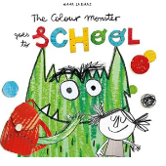
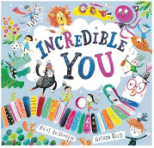
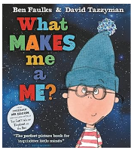
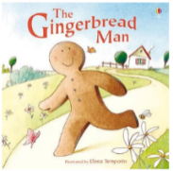
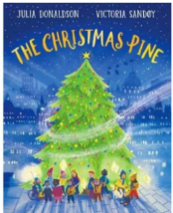
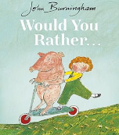
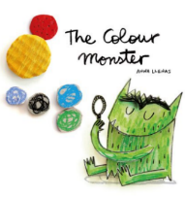
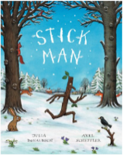
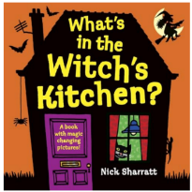
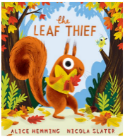
Autumn
Term

Reception
Physical Development:
Our focus is on fine and gross motor skills throughout this term including duster disco, climbing, playdough and Squiggle While You Wiggle activities. In PE the children will focus on building strength in their legs, hand eye coordination and will be practising negotiating space when playing racing and chasing games.

Personal, Social and Emotional Development
Scarf- Me and my relationships & Valuing Difference
Creating class rules and learning the class / school routines.
Understanding ways to be kind to each other.
Focus on independence, e.g. toileting, putting on coats, taking jumpers on and off, getting dressed etc.

Supporting the children to build positive relationships with adults and their peers, learning to take turns with one another and understand each other’s feelings.

Using the story ‘the colour monster’ and ‘It’s ok to be different’ to talk about emotions and help the children to self-regulate and celebrate what makes them ‘special’.

Getting to know each other through circle time games.

Discussing how to keep our bodies healthy.

RE
What makes us special?
What are special times?

Understanding the world
This term, children will explore themselves, their families and the world around them. In our Marvellous Me topic, they will talk about their own experiences and memories, explore how they have changed over time and develop an understanding of the people and places that are important to them. As we move into our Look at Us Glow! topic, children will explore different celebrations and traditions, learning about how people celebrate special times in different ways.
- Exploring our families, homes and the people who are important to us
- Looking at photographs and talking about memories and experiences from the past
- Talking about how we have changed as we have grown
- Exploring our classroom and developing a sense of belonging
- Exploring the natural world and spotting signs of Autumn
- Beginning to understand how changing seasons affect the world around us
- Learning about different festivals and celebrations, including Halloween, Diwali and Christmas
- Exploring family traditions and how different people celebrate special occasions
- Learning about Remembrance Day and why we remember
- Exploring the Christmas story and Christmas traditions

Mathematics
Develop understanding of number through play, recognition and comparison.
Number & Numerical Patterns
Count with 1:1 correspondence (accurately touch items)
Explore number bonds to 5 (5 and how it's made).
Compare sets using language: more, fewer, same.
Match, sort, and compare amounts (same/different, more/less).
Recognise numbers to 5 and begin accurate counting.
Subitise (instant recognition) within 3.
Explore numbers using fingers, objects, and Numberblocks
Shape, Space & Measures
Recognise and describe simple 2D shapes (circle, triangle, square)
Begin to use positional language (on, under, behind)
Explore repeating patterns (AB, ABB)
Mastering Number Focus
Comparing quantities.
Introducing 5-frame and finger patterns for numbers to 5.

Literacy
This term, children will develop a love of books and stories while building the foundations for reading and writing. They will enjoy sharing a range of stories, rhymes and texts, developing their understanding of characters and events. Through phonics and Drawing Club, children will begin to link sounds to letters and use the sounds they have learnt to support their early writing and mark making.

Autumn 1

Write some letters accurately.

Communication and Language
This term is all about getting to know each other and developing children's confidence to communicate with the people around them. Children will be encouraged to talk about themselves, their families, experiences and feelings. They will take part in group activities, learning to listen to others, take turns in conversations and share their ideas. Through stories, role play and small-world play, children will develop their vocabulary and begin to use language to recreate familiar experiences.
As we move into our Look at Us Glow! topic, children will continue to develop their communication skills by talking about special times, celebrations and family traditions. They will be encouraged to share their own experiences, listen to the experiences of others and develop vocabulary linked to celebrations and traditions.

Expressive arts and design
This term, children will explore different ways to express themselves through art, music, movement and imaginative play. Through our Marvellous Me topic, children will explore self-portraits, colour, pattern and different creative materials, while using role play to develop their ideas. As we move into our Look at Us Glow! Topic, children will explore art, music and role play linked to celebrations and special occasions.
- Creating self-portraits using a range of materials and techniques
- Exploring colour, pattern, texture and different art materials
- Developing ideas through drawing, painting, collage and loose parts
- Exploring music, sounds, rhythm and movement
- Using role play to recreate familiar experiences and celebrations
- Exploring imaginative play through small world and role play
- Creating artwork linked to Autumn and seasonal changes
- Exploring creative activities linked to Halloween, Diwali, Bonfire Night and Christmas
- Learning and joining in with songs, rhymes and music linked to celebrations
- Developing confidence to share and talk about our creative ideas

Phonics
Daily phonic sessions through Bug Club Phonics.
Phase 2 unit 1 s,a,t, p
Phase 2 unit 2 i, n, m, d
Phase 2 unit 3 g, o, c, k
Phase 2 unit 4 ck, e, u, r
Phase 2 unit 5 h,b, ff, l, ll, ss
Phase 3 unit 6 j, v
Phase 3 unit 7 w, x, y, z, zz
Phase 2 tricky words I, into, the, no, go and to.
Phase 3 tricky words me, be
We will learn the sounds made by the letters and also how to write each letter using the formation chants.
We will begin to orally blend by merging sounds we hear to make words.
We will learn how to orally segment using ‘sound buttons’ to break words up into sounds.

Drawing Club
Through Drawing Club the children will focus on one book per week and explore character, setting and adventure, applying their growing understanding of story structure and imagination.

